**Hand Book**

**Foundation of Green Skilling**

**Disclaimer: The content is curated from online/offline resources and used for educational purpose only**

**Table of Contents**

Learning Outcomes ii

Chapter 1: Green skilling and Sustainability 3

1.1 Introduction 3

1.2 Environmental Awareness and Literacy 3

1.3 Sustainable Practices and Resource Management 7

1.4 Green Technologies and Innovation 16

1.5 Adaptation to Green Job Markets 19

1.6 Government and Institutional Support 21

1.7 Role of Education and Training Institutions 25

References: 58

# Premium Vector | White abstract background in 3d paper style | Abstract backgrounds, Abstract, Geometric backgroundLearning Outcomes

After completing this handbook, learner will be able to

**Chapter 1: Green skilling and Sustainability**

|  |
| --- |
| **Learning Outcomes:**  By the end of this chapter, students will be able to:   * Understand the role of green skills in supporting sustainable economies and tackling environmental challenges. * Explain key environmental concepts like ecological and carbon footprints, and ways to reduce them. * Analyze strategies for promoting environmental literacy, sustainable practices, and resource management. * Recognize the role of governments, institutions, and global agreements (e.g., Paris Agreement, SDGs) in sustainability efforts. * Apply sustainable practices in daily life and business, such as waste reduction and energy conservation. |

# 1.1 Introduction

There are various challenges the world is facing concerning the environment, such as climate change and resource depletion. Green skills therefore play a vital role in the realization of green economies. Green skills refer to the know-how and skills that can support sustainable, low-carbon economies. Such skills are essential in many areas such as energy, agriculture, to name but a few, which play a crucial role in enabling persons and organizations build a better environment.

This chapter discuses the important issues on green skilling on areas such as environmental awareness, sustainable practices, green technologies, and the increase in the demand for green jobs. Governments, education, and training also fall under discussion to achieve a bright, sustainable future for all.

# 1.2 Environmental Awareness and Literacy

This is brought through environmental awareness and literacy, which helps the public and business entities realize their connectivity to the environment, understand the important issues, and make effective strides that reflect lifestyle of sustainability. This section covers definition, importance, core elements, and strategies in improving environmental literacy, and all of it just takes shape with the help of key concepts such as ecological footprint, carbon footprint, education.

Environmental literacy is the ability to know and act toward the solution of environmental problems. It encompasses a corpus of knowledge of natural systems, environmental issues, and their solutions as well as skills and motivation to undertake civic and environmental actions. The UN underlines the importance of environmental literacy for sustainable development and for involving people in solving the problems which affect the environment.

## 1.2.1 Importance of Environmental Awareness

**Informed Decision-Making**

Environmental literacy empowers an individual to make better decisions that impact their personal lives and communities. For example, knowledge about carbon footprints inspires one to embrace public transportation, renewable energy, and other sustainable practices.

**Sense of Responsibility**

Environmental awareness gives a sense of responsibility towards nature. It shows people the value of biodiversity and one's role in conservation by creating proactive behaviors such as conservation and resource management.

**Empowerment for Action**

A literate public on the environment is better positioned to advocate for its protection through policy measures, activism, and conservation practices at the grass roots level.

**Enhanced Quality of Life**

A relationship with nature is believed to positively impact mental health and overall well being. A healthy environment is conducive to the quality of life, which underscores protection of the natural ecosystems through sustainable practices.

## 1.2.2 Ecological Footprint and Carbon Footprint Education

Ecological Footprint and carbon footprint are such fundamental features of environmental knowledge that it becomes feasible for individuals and companies to comprehend measurable consumption implications for the accessible natural resources and the environment.

### Ecological Footprint

An ecological footprint calculates the amount of biologically productive land and water needed by an individual, organization, or population to make the resources it uses and absorb the waste it produces, especially carbon emissions. This involves land use for agriculture, forestry, energy production, and infrastructure.

* **Impact on Resource Consumption:** A low ecological footprint equates to the consumption of resources. It includes local purchases, waste reduction, and using renewable energy. It informs the individual and organization to reduce their dependency on resources, improve the efficiency in which they use resources, and save more.

### Carbon Footprint

The carbon footprint is measured as the aggregation of all greenhouse gases (GHG) directly or indirectly released by an individual or business, measured in tons of CO2 equivalent and includes emissions resulting from fossil fuel usage, transportation, energy usage, and industrial processes.

* **Strategies for Reduction:** Carbon footprint education empowers individuals and businesses to make sustainable choices, such as:
* Using alternative renewable energy sources such as solar or wind power.
* Energy consumption should be minimized through energy-efficient appliances and sustainable building practices.
* Use environmentally friendly transportation, such as walking, cycling, or electric vehicles.
* Reduce waste by recycling and upcycling to lower the demand for new raw materials and consequently energy used in producing them

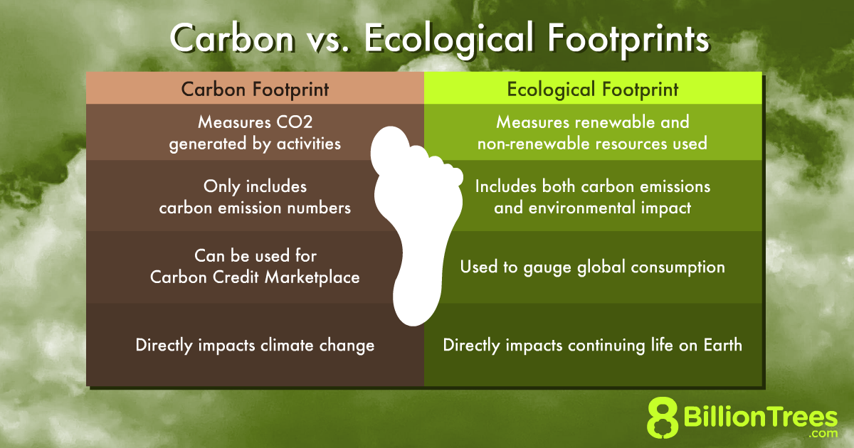

Source: https://8billiontrees.com/carbon-offsets-credits/carbon-ecological-footprint-calculators/globally-green-environment/

## 1.2.3 Components of Environmental Literacy

Environmental literacy consists of key components that shape awareness and action:

**Awareness and Sensitivity:** Taking notice of environmental problems and awareness of consequences at the local, regional, national, and global levels.

**Knowledge:** Gaining knowledge of ecological principles, environmental systems, and the interconnectedness of human behavior and natural phenomena, including components of ecological as well as carbon foot printing.

**Skills:** Developing critical thinking, problem-solving, and decision-making skills that allow people to face environmental issues, including calculating and decreasing their ecological and carbon footprint.

**Attitudes:** A sense of environmental responsibility that motivates them toward sustainable actions to decrease footprints.

**Participation:** Engaging in efforts that contribute to resolving environmental issues, from personal actions like footprint reduction to participating in global initiatives like climate change advocacy.

## 1.2.4 Strategies for Enhancing Environmental Awareness and Literacy

**Education Programs:** School and community-based learning programs should be made much more comprehensive to include hands-on experiential learning to learn an individual's ecological footprint and carbon footprint.

**Community Engagement:** Community-wide workshops, clean-up projects, and sustainability initiatives enhance the consciousness of the communities and encourage collaborative action to address issues affecting the environment.

**Technology Utilization:** Software applications such as footprint calculators facilitate the implementation of sustainability practices, which help citizens monitor and reduce their ecological and carbon footprint by keeping them informed.

**Lifelong Learning:** The practice of continuous learning in the subject area of environmental issues would impact because individuals would be up to date with what was happening in the field of ecological science, and what was actually being implemented in terms of sustainability practices.

## 1.2.5 Global Environmental Agreements and Policies

The second dimension of environmental literacy is knowledge about international environment agreements, like the Paris Agreement and the Sustainable Development Goals (SDGs). These frameworks specify how individual, group, or country practices can be made to align with more general sustainability objectives.

* **Paris Agreement (2015):** A legally binding international treaty aimed at limiting global warming to below 2°C, with a more ambitious goal of 1.5°C.
* **Sustainable Development Goals (SDGs):** These 17 global goals address challenges such as poverty, inequality, and climate change. Goals like Goal 7 (Affordable and Clean Energy) and Goal 13 (Climate Action) directly contribute to sustainability efforts.

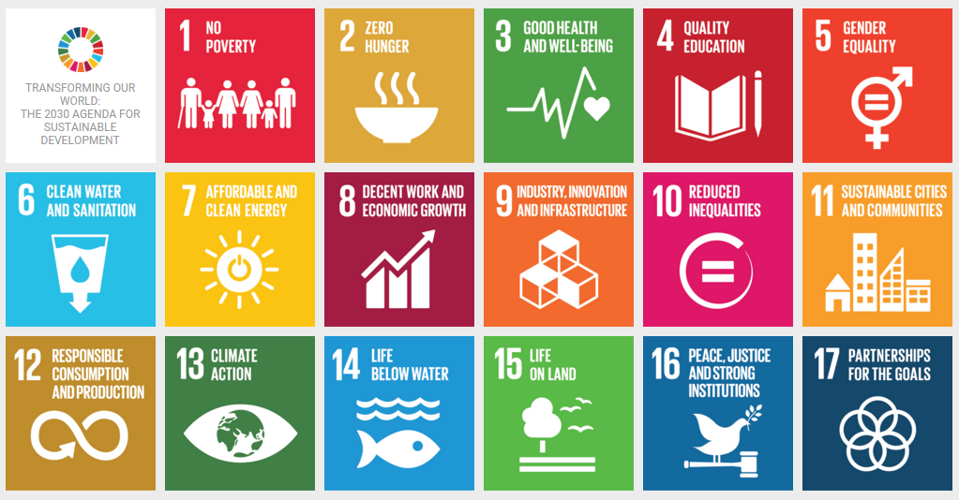

Source: https://www.iucn.org/our-work/informing-policy/international-policy/un-sustainable-development-goals

# 1.3 Sustainable Practices and Resource Management

Sustainability is the need satisfaction of the current generation without risking the ability of future generations to meet their needs.

Though it is a relatively new word, the definition of sustainability credited comes from Our Common Future, a report from 1987 by the United Nations (U.N.) Brundtland Commission. This landmark report was the culmination of years of data gathering and hearings with scientists, researchers, industry leaders, and governments around the world. It concluded that, to be able to solve diverse global environmental crises, the world needed to treat them as "interlocking crises" that must be addressed with holistic, sustainable solutions.

Clearly, sustainability is important to making our world habitable. However, for us to successfully take action to achieve a healthy balance between human needs and the capabilities of the Earth, there must be actual strides on waste reduction, conservation of natural resources, and keeping ecosystems healthy. Fortunately, people, organizations, and governments around the world set ambitious goals for doing this.

## 1.3.1 Why is Sustainability Important?

Sustainability is pivotal for several reasons, ranging from environmental protection to promoting social equity and economic stability. Some key points regarding the importance of sustainability are:

* **Environmental preservation:** This lies at the heart of the sustainability approach, where there should be responsible use of natural resources including, but not limited to, water, forests, and minerals so that these things are not depleted. Essential factors with regard to attaining this sustainability include cutting down greenhouse gas emissions as well as reliance on renewable energy to combat climate change.
* **Sustainable economic development:** Sustainability can lead to sustainable and steady long-run economic growth due to innovation and efficiency. For instance, clean technology and renewable energy sources can directly create employment.
* **Equity and social justice:** Social sustainability talks about equity and social justice, with the passage of time forwarding to developing a quality life for everyone, starting off with basic services such as health and education. Instead, they talk about equity and inclusion that try to narrow the differences in social and economic terms between the social classes.
* **Resilience and adaptation:** Sustainability enables the production of more resilient societies and economies that are better prepared to face unforeseen crises such as natural disasters or recessions and depressions.
* **Legacy for future generations:** This is premised on the principle of sustainable development whereby present needs are met without compromising the ability of future generations to meet their own needs.
* **Awareness and education:** It also promotes greater knowledge and awareness on human impacts on the world, this has the potential to result in long-term positive behavioural changes over time.

## 1.3.2 Types of Sustainability

According to the report compiled by the Intergovernmental Panel on Climate Change, even if the emissions of greenhouse gases are drastically cut off as of today, global warming is still likely to reach 1.5°C soon. This global warming might bring disastrous consequences, such as melting glaciers, disappearance of animal and plant species, start of forest fire and drought, etc.

Therefore, human being as well as business entities are significantly involved in the fight against climate changes and many activities for sustainability. Sustainability, however, is not environmental only; sustainability has to be brought about in many other ways also. In this context, it would like to be highlighted that sustainability assumes various forms.

The three pillars of Sustainability are Environmental Sustainability, Economic Sustainability and Social Sustainability.

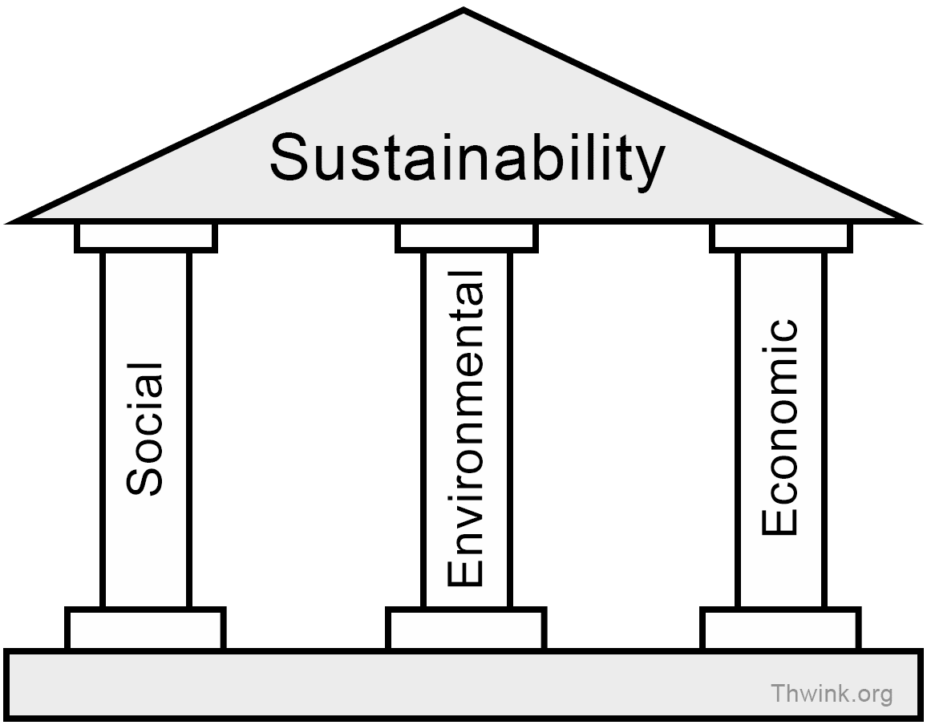

Source: https://earth.org/what-is-sustainability/

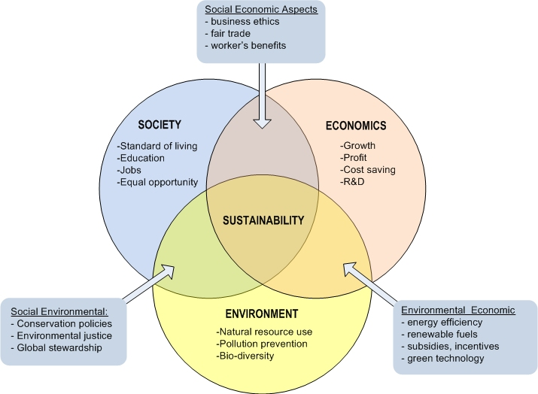

Source: https://www.e-education.psu.edu/eme807/node/575

### Premium Vector | White abstract background in 3d paper style | Abstract backgrounds, Abstract, Geometric backgroundEnvironmental sustainability

Environmental sustainability focuses on the conservation of biodiversity without giving up economic and social development. Foundations of Environmental Sustainability: Preserve water, save energy, reduce waste, use recyclable packs, limit or eliminate usage of plastics, sustainable transport, reuse paper, flora and fauna preservation.

A great example of environmental sustainability is Swachh Bharat Abhiyan (Clean India Mission): This large-scale campaign aims to ensure sanitation and waste management, promoting a cleaner environment and improving public health.

From the perspective of the sustainability development, at least six of the United Nations Sustainable Development Goals concentrate on environmental sustainability:

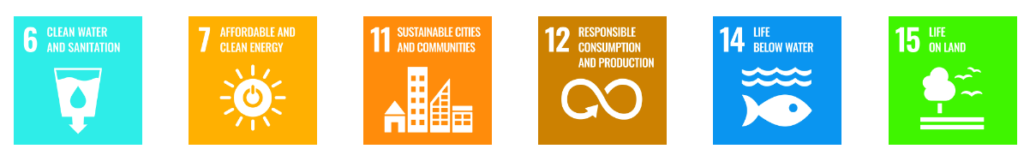

### Economic sustainability

In the case of a setting a company, the time that a company is developed involves setting the expenses and revenues. After a balance between these two factors is struck, the company makes profits. Economic sustainability is the ability of the organisation to responsibly utilize its resources and produce long-term profits.

For example, Unilever is the company which, in 2010, started a program to maintain the set balance between sustainability and economic performance of the company. Some measures to maintain the set condition were raising package recycling, encouraging the usage of recycled materials, and campaigns regarding responsible consumption.

From a sustainable development perspective, nine of the UN SDGs - including the first five - focus on social sustainability:

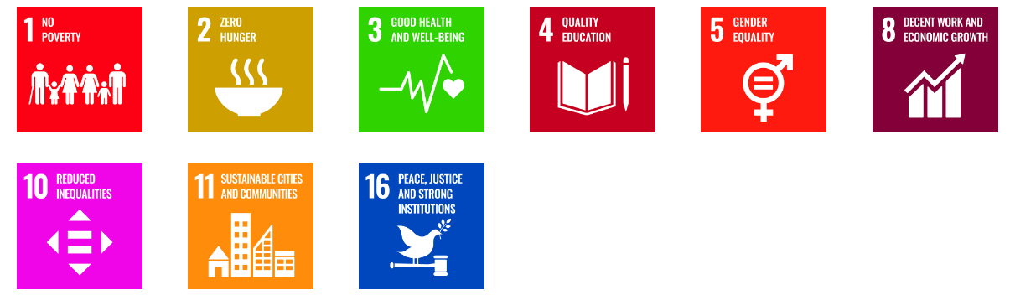

### Social sustainability

In any community in which economic activities are carried out in a specific environment, we find three interconnected forms of sustainability: environmental, economic, and social. In other words, social sustainability in particular has the goal of strengthening the cohesion and stability of specific social groups.

The government runs several programs, such as Mahatma Gandhi National Rural Employment Guarantee Scheme, which provides employment and social security for disadvantage groups.

From a sustainable development perspective, four of the UN SDGs directly focus on economic sustainability:

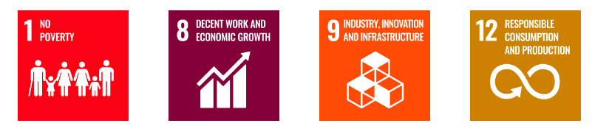

## 1.3.3 How to Apply the Three Pillars of Sustainability

The three pillars of sustainability—environmental, social, and economic—are the key framework for making decisions about how much weight people, the planet, and prosperity will get. Each pillar needs to be interpreted differently, but a helpful way to consider the three pillars is by using it more as a checklist on which sustainable decision-making or analysis can be checked off in different areas.

For example, think of the scenario where we were urban planners considering a new curbside recycling program in our city. Let's apply the three pillars to ask relevant questions, considerations, and impacts:

* **Environmental:** Does this initiative net positively on the environment? For example, is recycling more impactful on the environment, what are the environmental emissions as you drive around in a hopefully electric vehicle to pick up items? Indirect environmental impact?
* **Social:** Is this initiative good for all people? Who benefits? Is it fair and equitable to everyone? Are there any unintended consequences or social impacts?
* **Economic:** Is the project financially sustainable? For instance, if it costs us more money to recycle each item than we have in our program budget from taxes or other funding, our initiative might be great for the environment and society, but still not pass the economic sustainability test.

The three pillars inside companies can be used as a guiding model toward strategy corporate social responsibility (CSR), social impact, ESG (environment social governance), and sustainability strategy, prioritization, and decision-making.

Ultimately, when all the three pillars of sustainability are achieved and balanced, the governments, organizations, projects, and other initiatives towards the development would be more robust, resilient, long-lasting, and successful. Sustainable living is all of our collective responsibility, and the three pillars of sustainability can be a useful framework for making the right, sustainable decisions as well as asking and analysing the right questions about what's truly sustainable.

## 1.3.4 Sustainable Practices for Resource Management

Sustainable practices and resource management focus on using natural resources efficiently to meet current needs without compromising the ability of future generations to meet their own. This concept extends to both the personal and organizational levels, emphasizing the need for mindful consumption, waste reduction, and ecological stewardship.

**Principles of Sustainable Resource Management**

* **Resource Efficiency**: Optimizing the use of natural resources (energy, water, raw materials) to maximize their benefits and reduce waste.
* **Circular Economy**: Transitioning from a linear economy (take, make, dispose) to a circular model, where resources are reused, repaired, and recycled to minimize waste.
* **Life Cycle Assessment (LCA)**: Evaluating the environmental impact of a product or process from cradle to grave (production to disposal) and implementing strategies to reduce its footprint at each stage.

**Energy Conservation and Efficiency**

* **Renewable Energy Sources**: Utilizing solar, wind, hydro, and biomass energy to reduce reliance on fossil fuels and minimize carbon emissions.
* **Energy-efficient Technologies**: Promoting energy-saving devices and systems such as LED lighting, energy-efficient appliances, and smart energy management systems (e.g., IoT-enabled devices).
* **Green Building Practices**: Designing and constructing buildings that optimize natural light, ventilation, and insulation, and incorporate renewable energy sources.
* **Demand-side Management (DSM)**: Programs encouraging consumers to reduce their energy usage during peak demand periods to improve grid efficiency.

**Examples:**

* Implementation of energy-saving measures in households or organizations to cut down electricity consumption.
* Case studies showcasing businesses transitioning to renewable energy sources to meet their operational needs.

**Water Conservation and Management**

* **Water-efficient Technologies**: Installation of low-flow faucets, toilets, and water-efficient appliances (washing machines, dishwashers) to reduce water wastage.
* **Rainwater Harvesting**: Collecting and storing rainwater for reuse in irrigation, cleaning, and other non-potable applications.
* **Wastewater Treatment and Reuse**: Recycling greywater and treated wastewater for industrial, agricultural, and landscaping purposes.
* **Integrated Water Resource Management (IWRM)**: Holistic management of water resources that balances social, economic, and environmental objectives.

**Examples:**

* Large-scale adoption of rainwater harvesting systems in urban areas or industries.
* Government policies or community initiatives aimed at sustainable groundwater management.

**Waste Management and Recycling**

* **Reduce, Reuse, Recycle (3Rs)**: Encouraging minimal resource consumption (reduce), creative reuse of products (reuse), and processing waste materials into new products (recycle).
* **Composting and Organic Waste Management**: Composting food and organic waste to create nutrient-rich soil additives that reduce the need for chemical fertilizers.
* **E-Waste Recycling**: Managing electronic waste (old computers, phones, batteries) through proper recycling channels to recover valuable materials and prevent harmful chemicals from contaminating the environment.
* **Zero Waste Practices**: Reducing waste to landfill by redesigning production processes, improving product durability, and maximizing recycling efforts.

**Examples:**

* Municipal or corporate recycling programs.
* Innovations in waste-to-energy systems that convert waste materials into electricity or fuel.

**Sustainable Agriculture and Land Use**

* **Permaculture**: Designing agricultural systems that mimic natural ecosystems, promoting biodiversity, soil health, and resource conservation.
* **Regenerative Agriculture**: Farming techniques that restore soil health, increase biodiversity, and capture carbon to combat climate change.
* **Agroforestry**: Integrating trees and shrubs into agricultural lands to enhance biodiversity, soil stability, and resource efficiency.
* **Organic Farming**: Reducing chemical inputs by relying on natural fertilizers, crop rotation, and biological pest control to maintain long-term soil fertility.

**Examples:**

* Organic farms employing regenerative practices to restore ecosystems while producing crops.
* Governments or organizations providing incentives for sustainable farming practices.

**Sustainable Supply Chain Management**

* **Ethical Sourcing**: Ensuring that raw materials and products are sourced in ways that minimize environmental impact and respect human rights (e.g., fair trade).
* **Sustainable Procurement**: Favoring suppliers who prioritize sustainability in their operations, from energy use to waste management and labor practices.
* **Green Logistics**: Reducing the environmental impact of transportation and distribution systems through route optimization, fuel efficiency, and eco-friendly packaging materials.

**Examples:**

* Companies that have redesigned their supply chains to reduce their carbon footprint or water usage.
* Brands sourcing materials from certified sustainable sources (e.g., FSC-certified wood).

**Sustainable Urban Planning and Development**

* **Green Urban Spaces**: Designing cities with green roofs, parks, and community gardens to enhance air quality, support biodiversity, and provide spaces for recreation.
* **Sustainable Transportation Systems**: Encouraging the use of public transport, cycling, walking, and electric vehicles to reduce urban carbon emissions.
* **Smart Cities**: Using data and technology to improve the efficiency of resource management, from energy use in buildings to waste collection and transportation systems.

**Examples:**

* Initiatives in cities like Copenhagen or Singapore where smart city concepts are integrated with sustainability goals.
* Urban development projects prioritizing green infrastructure to manage stormwater, reduce heat islands, and improve residents’ quality of life.

**Behavioural and Cultural Change for Sustainability**

* **Education and Awareness Campaigns**: Promoting environmental literacy and resource conservation behaviours through campaigns in schools, workplaces, and communities.
* **Corporate Social Responsibility (CSR)**: Companies adopting sustainability as a core value, implementing green policies, and encouraging employees to participate in sustainability efforts.
* **Community-led Initiatives**: Grassroots movements encouraging sustainable lifestyles, such as local clean-up drives, tree-planting events, or carpooling networks.

**Examples:**

* Awareness campaigns targeting consumers to reduce single-use plastic.
* Companies encouraging employees to adopt eco-friendly commuting or office practices.

**Sustainable Tourism and Ecotourism**

* **Ecotourism**: Promoting travel experiences that respect the environment and local cultures, minimizing the negative impact on ecosystems.
* **Sustainable Hotels and Resorts**: Using green practices, such as energy-efficient buildings, waste reduction, and water conservation, to minimize the environmental footprint of tourism.

**Examples:**

* National parks implementing sustainable visitor management practices.
* Eco-friendly hotels and tour operators that promote conservation and engage in community development.

**Governance and Regulatory Frameworks**

* **Environmental Legislation**: Policies and regulations at local, national, and international levels that enforce sustainable resource management.
* **Incentive-based Policies**: Governments offering tax breaks, subsidies, or grants to companies or individuals who adopt sustainable practices or invest in green technologies.
* **International Cooperation**: Collaboration between countries to promote global sustainability standards, such as carbon markets or sustainable fisheries agreements.

**Examples:**

* National environmental protection laws that regulate pollution, waste management, and resource use.
* International agreements on climate change and biodiversity, such as the Paris Agreement and the Convention on Biological Diversity (CBD).

# 1.4 Green Technologies and Innovation

Green technologies and innovations are essential for addressing environmental challenges while driving sustainable economic growth. These technologies minimize negative environmental impacts, promote resource efficiency, and offer innovative solutions for industries, governments, and individuals to reduce their carbon footprint.

## 1.4.1 Definition and Importance of Green Technologies

* Green Technologies and Innovation refer to the development and application of environmentally friendly and sustainable technologies aimed at addressing environmental challenges like climate change, resource depletion, and pollution.
* Green technologies help achieve sustainability goals by reducing carbon emissions, conserving natural resources, and promoting renewable energy sources.

**Examples:**

* Adoption of solar panels and wind turbines for clean energy generation.
* Development of electric vehicles (EVs) to reduce transportation-related emissions.

## 1.4.2 Renewable Energy Technologies

* **Solar Power**: Photovoltaic (PV) panels convert sunlight into electricity, offering a renewable and abundant source of energy. Innovations in solar panel efficiency, storage solutions, and solar farms have driven the expansion of solar power worldwide.
* **Wind Energy**: Wind turbines harness wind power to generate electricity. Offshore and onshore wind farms contribute significantly to renewable energy portfolios, with innovations focusing on improving turbine efficiency and integration into power grids.
* **Hydropower**: Water turbines convert the kinetic energy of flowing water into electricity. Hydropower technologies focus on improving dam efficiency and developing low-impact, small-scale hydro projects that minimize environmental disruptions.
* **Geothermal Energy**: Extracting heat from the Earth’s crust to generate electricity and provide direct heating solutions. Geothermal power plants are expanding, with innovations in drilling and resource identification improving access to this renewable energy source.
* **Biomass and Bioenergy**: Biomass (organic material) is used to produce biofuels and bioenergy. Technologies like anaerobic digestion and biomass gasification provide renewable energy while reducing waste and promoting circular economy practices.

## 1.4.3 Energy Storage and Smart Grids

* **Battery Technologies**: Advancements in battery storage systems, such as lithium-ion and solid-state batteries, enable more efficient storage of renewable energy for use when the sun isn’t shining or the wind isn’t blowing. Innovations focus on improving energy density, reducing costs, and ensuring safety.
* **Smart Grids**: Intelligent power distribution systems that optimize energy use by managing electricity demand, integrating renewable sources, and ensuring grid stability. Smart grids rely on data, sensors, and automation to enhance energy efficiency and reduce energy loss.
* **Energy Storage Systems (ESS)**: Large-scale storage systems (e.g., pumped hydro, thermal storage) allow excess renewable energy to be stored and used later, increasing the reliability of renewable energy supplies.

**Examples:**

* Tesla Powerwall and other home energy storage solutions that enable households to store solar energy for later use.
* Smart meters that monitor and optimize energy consumption in real time.

## 1.4.4 Green Transportation Technologies

* **Electric Vehicles (EVs)**: EVs are powered by electricity instead of fossil fuels, significantly reducing greenhouse gas emissions. Innovations in battery technology, charging infrastructure, and autonomous driving are driving the widespread adoption of EVs.
* **Hydrogen Fuel Cells**: Hydrogen-powered fuel cells produce electricity through a chemical reaction, with water as the only byproduct. Fuel cell technology is being explored for transportation applications, especially in heavy-duty vehicles, buses, and long-haul trucks.
* **Sustainable Aviation**: Electric and hybrid-electric aircraft, as well as sustainable aviation fuels (SAF), are reducing the carbon footprint of air travel. Innovations focus on improving fuel efficiency and developing alternative propulsion systems.
* **Shared Mobility and Smart Transportation**: Car-sharing platforms, bike-sharing systems, and autonomous vehicles contribute to reducing traffic congestion, emissions, and the environmental impact of personal transportation.

**Examples:**

* The rise of electric vehicles such as Tesla, Nissan Leaf, and Rivian, and their impact on reducing emissions.
* Hydrogen-powered buses and trains being implemented in regions like Japan and Europe.

## 1.4.5 Water Conservation Technologies

* **Desalination and Water Purification**: Technologies that convert seawater into fresh water through processes like reverse osmosis are helping regions with limited freshwater access. Innovations focus on improving the efficiency and reducing the cost of desalination.
* **Water Recycling Systems**: Greywater recycling and water treatment technologies allow for the reuse of water in irrigation, industrial applications, and even domestic use, reducing the strain on freshwater resources.
* **Smart Irrigation Systems**: These systems use sensors and data analytics to optimize water usage in agriculture, reducing waste and improving crop yields.

**Examples:**

* Israel’s innovative use of desalination and drip irrigation systems for water conservation in agriculture.
* Smart water meters that track water usage in real time, enabling households and businesses to reduce waste.

## 1.4.6 Sustainable Agriculture Technologies

* **Precision Agriculture**: Using data analytics, drones, and GPS technology, farmers can optimize water use, fertilizer application, and pest management, reducing environmental impacts while improving crop yields.
* **Vertical Farming**: Growing crops in vertically stacked layers within controlled environments (indoor farms) that use less land, water, and energy compared to traditional farming methods.
* **Aquaponics and Hydroponics**: These systems use fish and water-based farming techniques to grow plants without soil, reducing water use and enabling food production in urban environments.

**Examples:**

* Indoor vertical farms like AeroFarms and Bowery Farming that grow fresh produce year-round using a fraction of the resources.
* The use of drones in agriculture for crop monitoring and precision spraying.

# 1.5 Adaptation to Green Job Markets

The future of work is green. The United Nations says the world's global economy is "greening," as sectors like energy, transport, and construction become more sustainable. That process alone could create 24 million more jobs around the world by 2030, putting a premium on workers with green skills.

However, supply lags as demand spills into other areas, such as economics and finance, security, market and geopolitical analysis, communications, social sciences, and legal. According to the International Labor Organization, "green jobs reduce the consumption of energy and raw materials, limit greenhouse gas emissions, minimize waste and pollution, protect and restore ecosystems, and enable enterprises and communities to adapt to climate change.".

Demand for green skills far outpaces supply. According to LinkedIn's Global Green Skills Report, between 2022 and 2023, at least one job posting required a minimum number of green skills to grow by 22.4 percent while the share of green talent in the overall workforce only grew by 12.3 percent.

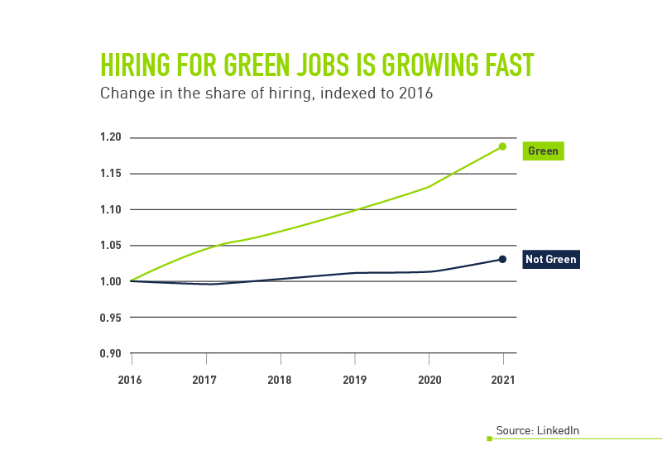

Source: <https://www.peoplescout.com/insights/green-jobs-green-skills-hiring-for-a-renewable-future/>

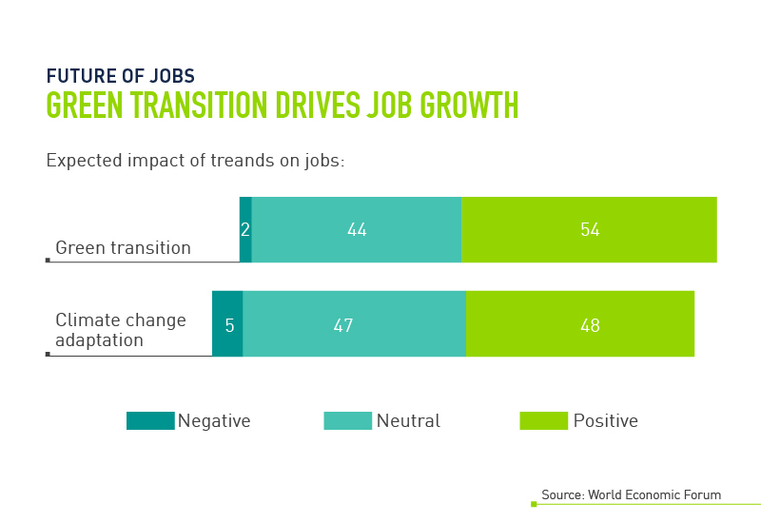

Source: https://www.peoplescout.com/insights/green-jobs-green-skills-hiring-for-a-renewable-future/

So far, most green job growth has come in some of the highest-polluting industries-energy and transportation-and in some of the countries that produced the most greenhouse gases. The U.S., Germany, and India, countries that emit some of the highest amounts of greenhouse gasses, are leading the way in green jobs. Says the World Economic Forum, "Germany is embracing more green skills in manufacturing, while in the U.S. and India oil and gas and mining-related skills are on the rise." But green jobs are more than installing solar panels and building electric vehicles. "The finance sector will be one of the most important in sustainability, but remains woefully behind," according to LinkedIn. Huge investments into things like wind farms and electric vehicle charging stations will be required for the fight against climate change, and finance professionals will take center stage. Still, only 6.8% of finance workers worldwide possess green skills. Silver linings generally represent good news; in this case, green jobs in finance are growing. Between 2021 and 2022, the percentage of green jobs in finance grew by 17%. With competition for green talent also on the rise, it is important for employers to come up with an in-depth understanding of the most in-demand green skills, as well as how to attract, hire, and train top talent.

Some key terms relating to the green skill industry:

**Green jobs:** these are those that one cannot perform without deep knowledge of the green skill 24

**Greening jobs:** one can perform these without green skills but do require some degree of green skills 25

**Greening potential jobs:** one can perform these without green skills but sometimes they require some degree of green skills

**Non-green jobs:** those that don't necessarily need green skills to perform

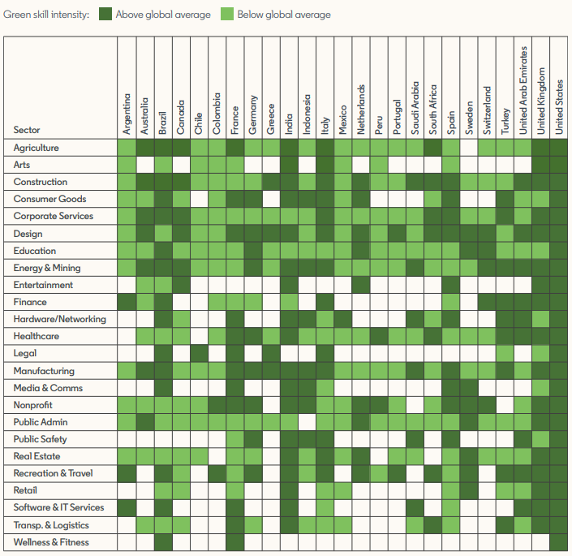

Source: https://economicgraph.linkedin.com/content/dam/me/economicgraph/en-us/global-green-skills-report/global-green-skills-report-pdf/li-green-economy-report-2022.pdf

# 1.6 Government and Institutional Support

In any case, governments and institutions play a very important role in ensuring sustainability. Support for the green city idea can take many forms-including legislations, funding, research and developments, public-private partnerships, and education initiatives.

## 1.6.1 Legislation and Policy Frameworks

**Environmental Laws and Regulations:** The policies determined by the government are decided upon by the laws enacted in various jurisdictions, creating standards for emission management, waste management, and resource conservation. This put companies into cleaner technology and practices.

**Green Technology Incentives:** Financial incentives such as tax credits, grants, and subsidies encourage businesses and individuals to invest in renewable energy, energy efficiency, and sustainable practices.

## 1.6.2 Research and Development Funding

* **Innovations Green:** Grants are usually offered by the government to research and universities for developing new technologies that solve environmental problems.
* **Cooperation of Government, Academic, and Private Sector:** It provides cooperation that allows knowledge sharing and facilitates the commercialization of green technology.

* **Research Grants and Competitions:** The funding through such programs encourages start-ups and researchers to look forward to a sustainable future by coming up with innovative ideas for greening.

**Examples**

* Government grants on renewable energy research. Examples include grants by the U.S. Department of Energy.

* Public-private partnerships that fund pilot projects on sustainable agriculture or clean energy technologies.

## 1.6.3 Public Awareness and Education Initiatives

* **Environmental Education Programs:** State governments and institutions make environmental literacy to circulate at the school, university, and community levels through educational programs for building a green culture.
* **Awareness Campaigns for Taking up Sustainable Practices:** Public campaigns create awareness among people and their organizations to take on sustainable practices, if only with overtly commercial goals.
* **Training and Certification Programs:** Institutions provide professional training and certification programs in green technologies. Therefore, institutions prepare a skilled work force to meet the demands of the green economy.

**Examples:**

National programs focusing on education related to recycling and waste reduction, such as America Recycles Day.

Educational establishments incorporated sustainability into the curriculum.

## 1.6.4 Investment in Infrastructure for Sustainability

Installing infrastructure to generate renewable energy sources, such as solar farms, wind farms, and electric charging stations, is also furthered by the government.

* Public transportation should be built in a way that there is minimum usage of fossil fuels and maximum encouragement of sustainable commuting.
* **Waste management centers:** There should be developed more and better sites for recycling and resource recovery facilities which should help towards circular economy and wastage ought not to reach the landfills.

**Examples:**

* Government money spent on installing electric vehicle charging stations in every urban area
* Public transport investment that increases access to buses and trains, and cycling infrastructure.

## 1.6.5 International Cooperation and Agreements

In global environmental agreements, governments sign international treaties and agreements to commit to goals and climate actions toward sustainability, such as in the Paris Agreement and the Convention on Biological Diversity.

* **Collaboration with Other Nations:** Countries have a chance to work together on research, technology transfer, and best practices about global environmental challenges.
* **Global Initiatives:** Funding to International Initiatives Funding for International Initiatives Intended to Support Climate Change Mitigation and Conservation of Biodiversity in the Facilitation of Sustainable Development Funding to the Green Climate Fund.

**Examples:**

* Commitments made under the Paris Agreement to reduce greenhouse gas emissions and enhance resilience to climate impacts.
* Bilateral agreements between countries to share technologies and expertise in renewable energy.

## 1.6.6 Public-Private Partnerships (PPPs)

* **Collaborative Projects:** Pool resources and benefits from the private sector to develop and deliver sustainable projects.
* **Innovative Financing Models:** PPPs can leverage innovative financing models, such as green bonds, to fund sustainability projects but not necessarily from public funding alone.

* **Community Engagement:** Collaboration with local organizations and other local stakeholders ensures that projects deliver community needs while promoting sustainable practices.

Examples:

* Projects to be constructed as joint ventures of the government and private firms undertaking renewable energy projects or green infrastructures.
* **Community solar:** This program gives an opportunity for a resident to invest in or benefit from locally initiated solar energy projects.

## 1.6.7 Monitoring, Reporting, and Accountability

* **Environmental Monitoring Programs:** Governments track the following environment indicators to measure progress toward sustainability objectives: air and water quality, biodiversity, greenhouse gas emissions, etc.
* **Sustainability Reporting Obligations:** Policies that make reporting on the environmental impacts of an organization obligatory guarantee a sense of accountability and transparency.
* **Benchmarking and Performance Metrics:** Benchmarking performance metrics will be set by the government to measure if sustainability initiatives or policies are being implemented effectively.

Examples:

* The U.S. Environmental Protection Agency monitors air quality and has published data on emissions.

* Forced public traded companies to report about their environmental impact to investors and the public.

## 1.6.8 Addressing Environmental Justice

Equal Access to Resources: Government regulations ensure that all communities, but especially the disadvantaged and oppressed, have easy access to clean air, water, and green spaces.

Involving the Community in Decision Making: Involving the community in the sense of environmental planning and decision-making addresses issues of historical injustices and ensures they become participatory citizens in all matters of environmentalism.

Selective Support to Vulnerable Communities: Governments provide resources and capacity to vulnerable communities to empower them in the ability to change and respond to the impacts of environmental changes.

Examples include:

Neighbourhood quality improvements, which target low-income areas most affected by pollution.

Promote access to parks and open spaces as alternatives for use in underserved communities.

The government and institutions play a very big role in providing a push for sustainable initiatives and green technology on the ground, creating an enabling environment for innovation, responsible resource management, and support through legislation, funding, education, and collaboration.

# 1.7 Role of Education and Training Institutions

Amidst the nature of climate change, environmental degradation, and the ultimate shift to a sustainable economy, significant institutions of education and training must focus on supporting the development of the workforce for "green skills." These represent the knowledge, abilities, values, and attitudes required to support sustainability and environmental stewardship in different sectors.

Here a look into how educational and training institutions contribute to green skilling and sustainability:

## 1.7.1 Contribution of Educational and Training Institutions to Green Skilling and Sustainability

**I. Curriculum Integration and Green Education**

Sustainability can be included in the curriculum of institutions at all levels: primary, secondary, and tertiary. This enables children to learn about environmental education integrated within various subjects- including science and engineering, economics, and the arts. Through this mechanism, educational institutions can make students aware of global environmental challenges, their causes and possible solutions.

Focus: Science, technology, engineering, and mathematics (STEM) subjects are critical to developing some key skills in green sectors like renewable energy, sustainable agriculture, and environmental conservation.

Multidisciplinary Approach: Sustainability concepts applied across disciplines result in holistic learning for the students who learn what goes along in an interdependent relationship with the overall systems of environment, society, and economy.

Awareness About Environmental: An awareness program on environmental issues can be set up by the school and colleges as part of their endeavour. Workshops, campaigns, or a green initiative like planting trees, recycling, and so on can be undertaken in both schools and colleges to instil sustainable behaviours among its students.

**II. Vocational Training and Green Jobs**

Most importantly, vocational and technical institutes provide people with the training necessary for green occupations, especially in renewable energy, waste management, water conservation, and sustainable construction. The emergence of a green economy demands such skilled labour for these needs.

Some of the examples of vocational skills needed in green industries include: courses in solar panel installation and wind energy maintenance, as well as bioenergy production.

Sustainable Agriculture: The education imparts related training to ensure productivity by minimizing negative impacts on their environment through sustainable agriculture, organic farming, and agroforestry.

Circular Economy Skills: Reuse and recycling, upcycling, and waste-to-wealth methods of jobs skills for working in waste management and circular economy jobs.

**III. Research and Innovation**

Universities and research institutions are innovators in green technologies and practices. They play a part in making solutions which make energy efficiency, pollute lesser and create biodiversity through research and development.

Research into Green Technologies: Universities are involved in research on energy-efficient technologies, electric vehicles, sustainable building materials, and climate-resilient infrastructure which brings innovation in support of sustainability.

Sustainable Business Models: Business schools and entrepreneurship programs can guide the students to design and operate sustainable businesses that develop circular economy models and conduct ethical business practices.

**IV. Capacity Building and Professional Development**

Higher education institutions and technical institutes design continuous professional development, thus upskilling or reskilling professionals to have expertise in sustainability.

Executive Education: Short-term executive programs and training would mean an understanding of how ESG criteria affect business leadership in their own decision-making.

Green Certifications and Accreditation: Another component is that of green certification programs in areas such as energy efficiency, sustainable building, like LEED certification, and carbon footprint management. This way, professionals would be brought up to date with current trends and standards in the area of sustainability.

**V. Community Engagement and Awareness**

One of the major drivers of community-based sustainability initiatives occurs through the campus of educational and training institutions. Such institutions, in partnership with local communities, can nurture greener and environmentally friendlier practices and action both on and off campus.

Public Outreach Programs: Universities and schools can lead the way in community programs for climate change awareness drives, local environment clean-up drives, or even workshops about sustainable living such as conserved water use practices and energy saving.

NGO-Government Partnerships: Collaborate with the government and NGOs to scale green initiatives. Develop policies that enhance sustainability from the grassroot level.

**VI. Building a Green Workforce**

The institutions drive to ensure the graduates enter the workforce and support the establishment of a sustainable economy.

This is achieved through:

* In-embedding Green Skills in Core Subjects: In order to ensure that all students are educated on environmental and sustainability modules in all sorts of courses, whether business and engineering and law, their graduates are never going to lack any kind of basic sustainability knowledge.
* Apprenticeship and Practical Exposure: Tying up with green businesses and sustainability-driven organizations and governmental bodies can provide students with strong apprenticeships and practical exposure to initiatives in fields such as renewable energy, sustainable design, and environmental conservation.

**VII. Promoting the campus sustainability culture**

Such institutions can set examples on their campuses in actualizing sustainability. Energy, water, waste, and transportation sustainably are used on green campuses.

Green Buildings: Campuses can be designed using sustainable architecture, including efficient lighting, solar panels, or rainwater harvesting systems.

Policies for Sustainability: Universities can implement policies such as recycling programs, reduction of single-use plastics, and encouraging the use of public transport or electrical vehicles on campus.

**VIII. Global Networks and Policy Advocacy**

Global networks and policy advocacy have been a crucial tendency for higher education institutions to work together to advance the agenda of sustainability. In this, global networks and policy advocacy can contribute to the big-scale sustainability agendas of institutions.

Global Networks: Association with other international organizations, such as UNESCO's Global Action Programme on Education for Sustainable Development (GAP-ESD) or the United Nations' Sustainable Development Solutions Network (SDSN), can multiply the influences that the education sector could exert for sustainability.

Policy Formulation: The institution of learning can also influence national and international policies on sustainability and green growth by offering research, data, and expertise to inform the application of policies in the right direction.

Through fostering green skills and advancing sustainability, education and training institutions are put right at the heart of the action. From embedding key elements of sustainability within curricula; to facilitating vocational training in green jobs; through stimulating research and innovation in green technologies; and community engagement, these institutions empower future generations with skills, knowledge, and mindset to enter a new age of sustainable resilience. These institutions play a pivotal role, not only in fashioning the workforce of tomorrow but also in guiding society toward change for environmental stewardship and sustainability.

# References:

https://www.weforum.org/agenda/2024/02/green-jobs-green-skills-growth/

https://www.british-assessment.co.uk/what-is-sustainable-resource-management-and-how-do-you-achieve-it/

https://www.investopedia.com/terms/g/green_tech.asp

https://www.doe.virginia.gov/teaching-learning-assessment/instruction/environmental-literacy

https://earth.org/climate-change/

https://earth.org/environmental-education/

<https://www.britannica.com/topic/environmental-policy/Global-policy-agreements>

https://www.captechu.edu/blog/moving-towards-more-sustainable-future-using-ai

https://www.eea.europa.eu/en/topics/in-depth/climate-change-mitigation-reducing-emissions

https://www.ef.org/2019/08/20/energy-optimization-its-time-to-reimagine-energy-efficiency/

https://sarep.ucdavis.edu/sustainable-ag

https://agritech.tnau.ac.in/org_farm/orgfarm_introduction.html

https://www.usda.gov/topics/forestry/agroforestry

https://byjus.com/chemistry/water-management/

https://www.weforum.org/agenda/2024/09/ai-accelerator-sustainability-silver-bullet-sdim/

https://www.fdmgroup.com/news-insights/ai-and-sustainability/



**Disclaimer: The content is curated from online/offline resources and used for educational purpose only**